|  |  |
| --- | --- |
| **WC Logo.emf** | **Staff Report to the County Commission**  *Weber County Planning Division* |
|  | |

****Synopsis****

****Application Information****

**Application Request:** Consideration and action on a request for final approval of Vista View Subdivision, consisting of four residential lots.

**Agenda Date: Tuesday, June 15, 2021**

**Applicant:** Dean Jensen, owner

**File Number:** UVV021621

****Property Information****

**Approximate Address:** 403 S 8600 E, Huntsville

**Project Area:** 21.01 Acres

**Zoning:** Agricultural Valley (AV-3)

**Existing Land Use:** Vacant

**Proposed Land Use:** Residential

**Parcel ID:** 21-026-0014

**Township, Range, Section:** T6N, R2E, Section 17

****Adjacent Land Use****

**North:** Agricultural **South:** Residential/Agricultural

**East:** Residential **West:** Residential/Agricultural

****Staff Information****

**Report Presenter:** Felix Lleverino

flleverino@co.weber.ut.us

801-399-8767

**Report Reviewer: SB**

Applicable Land Use Codes

* Title 101 (General Provisions) Chapter 1 (Definitions)
* Title 104 (Zones) Chapter 6 (Agricultural Valley Zone, AV-3)
* Title 106 (Subdivisions) Chapter 1 (General Provisions) Section 8 (Final Plat Requirements)

Development History

On March 23rd, 2021, the Vista View Subdivision was granted preliminary approval based on the following conditions:

1. The subdivision plan shall meet all Weber County reviewing agency requirements before recording the final Mylar.
2. The owner record a covenant to advise the new lot owner the well permits must be obtained.
3. The owner enters into a deferral agreement for curb, gutter, and sidewalk on 8600 East and 500 South, and a deferral agreement for curb, gutter, sidewalk, and asphalt for the area dedicated on the north side of the development.

The subdivision plat shows the area dedicated for the future right-of-way easement, see Exhibit A. Before recording the plat, the Planning Division will require that the well covenant, deferral agreement, and that all other county agency requirements are satisfied. The County Engineer will not require a deferral agreement for the future public right-of-way easement on the north side of the development.

On May 25th, the Vista View Subdivision was granted final approval from the Planning Commission based on the following conditions:

1. The owner shall create an escrow account plus a 10% contingency fund for all remaining subdivision improvements before final approval from the County Commission.
2. The developer shall agree to dedicate land for the future right of way.
3. All final plat requirements shall be satisfied before going before the County Commission for final approval.

The escrow account has been created. The Well Covenant, Deferral Agreement, and Agreement to Dedicate will be recorded with the final plat.

Background and Summary

The applicant is requesting final approval of a Vista View Subdivision, consisting of four residential lots that front directly on 8600 East, and 500 South Streets, which are county public right-of-ways. This 21.01-acre subdivision contains one single-family dwelling within lot 3. The remaining lots are vacant farm ground.

The north edge of the property falls at a mid-point of a 2,539’ block and is an ideal location for an intersection from 8600 East Street. County agencies in co-operation with the developer have agreed that placing an easement for a future public right of way is the best option at this time. The dedication plat shall depict the 33’ future right of way easement and the developer will agree to dedicate the area for the public ROW.

The County Surveying and Engineering Departments have verified that 8600 E and 500 N streets will require right of way dedication. 8600 East Street will require asphalt widening. Mr. Dean Jensen has submitted funds that amount to $32,730.25 for the widening of 8600 East fronting the Vista View development.

This proposal has been reviewed against the current Weber County Land Use Code (LUC), and the standards of the AV-3 zone found in LUC §104-6. The following section is a brief analysis of this project against current land use regulations.

Analysis

*General Plan*: This proposal conforms with the Ogden Valley General Plan (OVGP) by encouraging low-density development under the existing three acre zoning (see page 21 of the OVGP).

*Zoning*: The property is located in the AV-3 Zone. The purpose of this zone is stated in the LUC §104-6-1.

*“The purpose of the AV-3 Zone is to designate farm areas, which are likely to undergo a more intensive urban development, to set up guidelines to continue agricultural pursuits, including the keeping of farm animals, and to direct orderly low-density residential development in a continuing rural environment.”*

*Roadway Dedication*: The subdivision plat will convey the area to public streets (see exhibit A). The property description extends to the center of the 8600 East and 500 South. According to 106-2-2 (a) “Streets in year-round subdivisions shall be dedicated to the county”.

*Culinary Water*: One well has been drilled which satisfies 106-4-2 (a)(3) the code requirements to have at least one well permit per development. The section of code also requires that the owner record a covenant that advises the new lot owner that well permits must be obtained, a well must be drilled, the water quality is satisfactory, and that water quantity is sufficient.

*Irrigation Water*: Mr. Jensen owns 20 shares of irrigation water from the Eden Irrigation Company.

*Sanitary System*: The Weber-Morgan Health Department has provided a feasibility letter stating that lots 1, 3, and 4 qualify for an at-grade wastewater disposal system. Lot 2 qualifies to utilize a Wisconsin Mound or Packed Bed Media system.

*Review Agencies*: The Weber County Fire District has posted approval of the subdivision request with the caveat that further requirements are applicable at the time of home construction. Weber County Engineering requires the deferral agreements to be recorded with the final plat. The Weber County Surveyors Office has posted approval of the final plat. The Planning Division is ready to approve this proposal following the recordation of the dedication plat.

Staff Recommendation

Staff recommends final approval of Vista View Subdivision, consisting of four lots. The following conditions are included with the Planning Staff’s recommendation:

1. The developer shall agree to dedicate land for the future right of way, and
2. Deferral agreements for curb, gutter, and sidewalk, and
3. A Well Covenant, which notifies the owners that a well will need to be drilled.
4. All final plat requirements shall be satisfied before final approval from the County Commission.

The following findings are the basis for the planning staff’s recommendation:

1. The proposed subdivision conforms to the Ogden Valley General Plan.
2. The proposed subdivision complies with the applicable County codes.

Exhibits

1. Vista View Estates final plat
2. Current Recorders Plat

Area Map

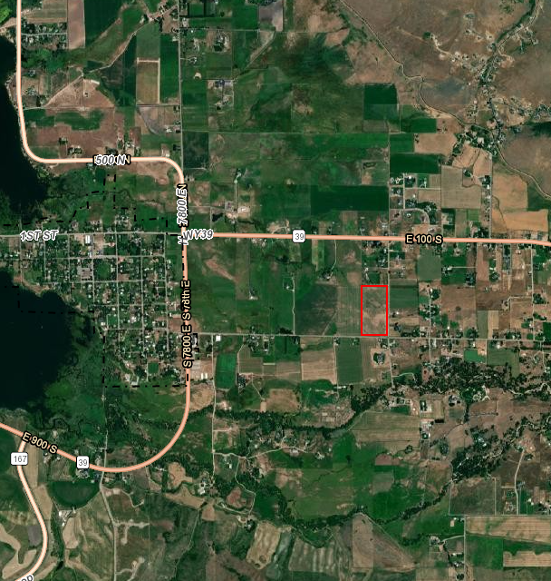

Exhibit A

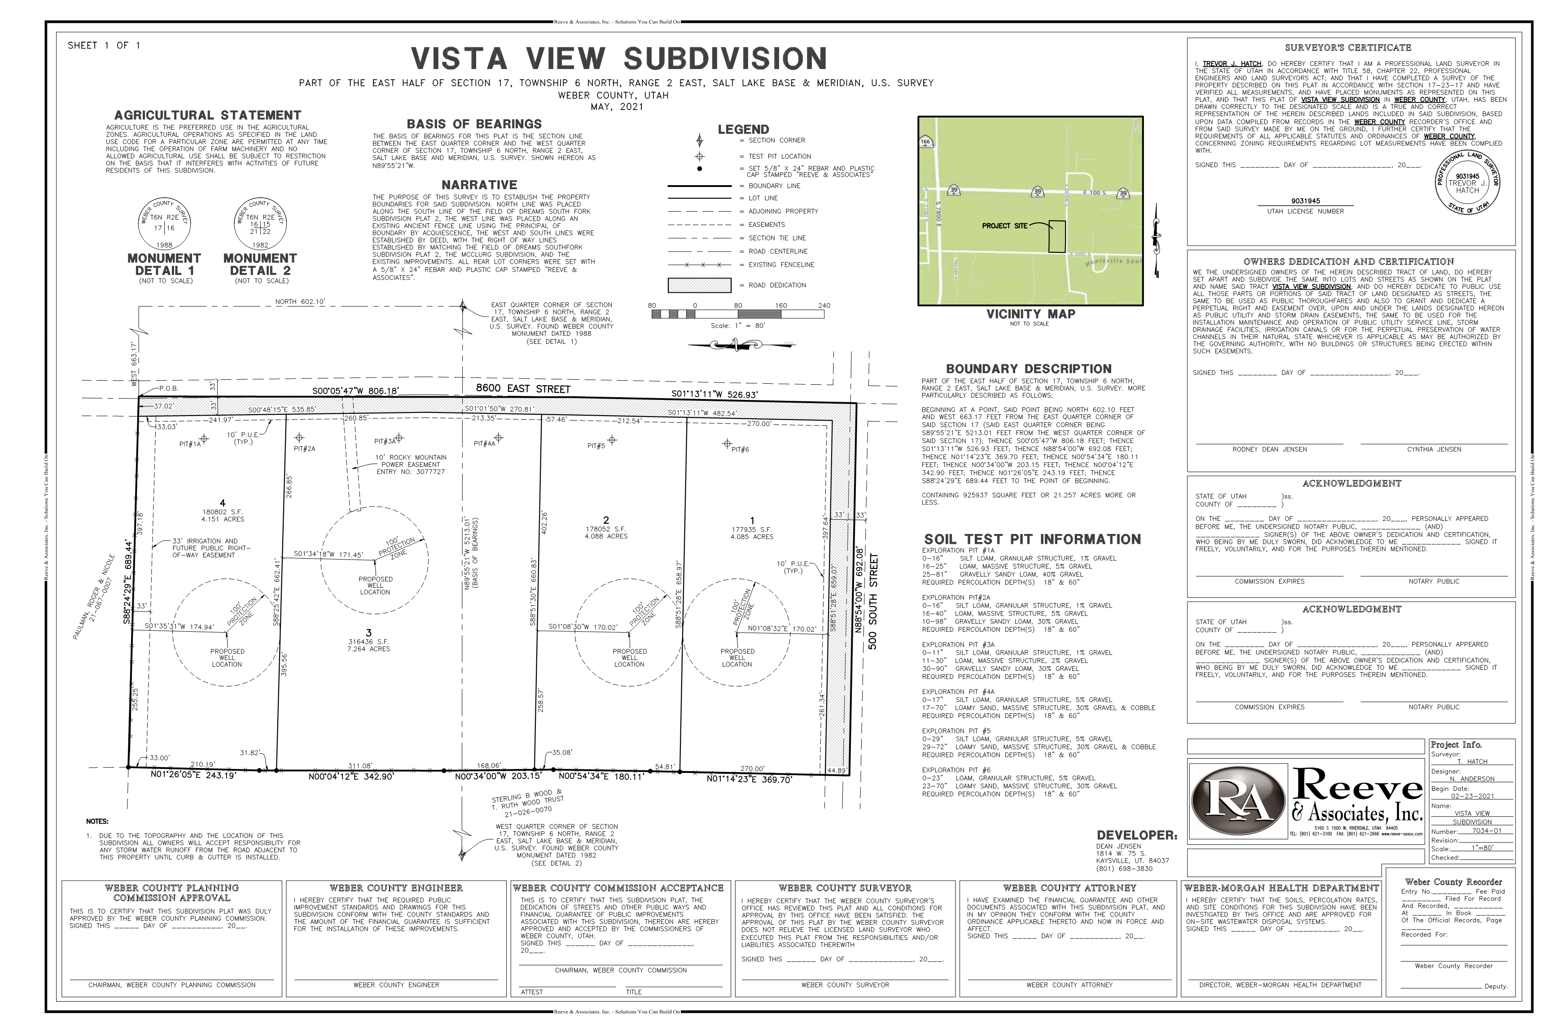

Exhibit B

